**Testing Document: Yllka Bokju & Sam Chard**

**Note:**

1. **The program does not restrict the user from entering any non letter characters. It the removes all the non letter characters except space.**
2. **The program only deals with letters (capital or small) and space.**
3. **If the user enters digits or punctuations or symbols the program removes from the string.**

# Results:

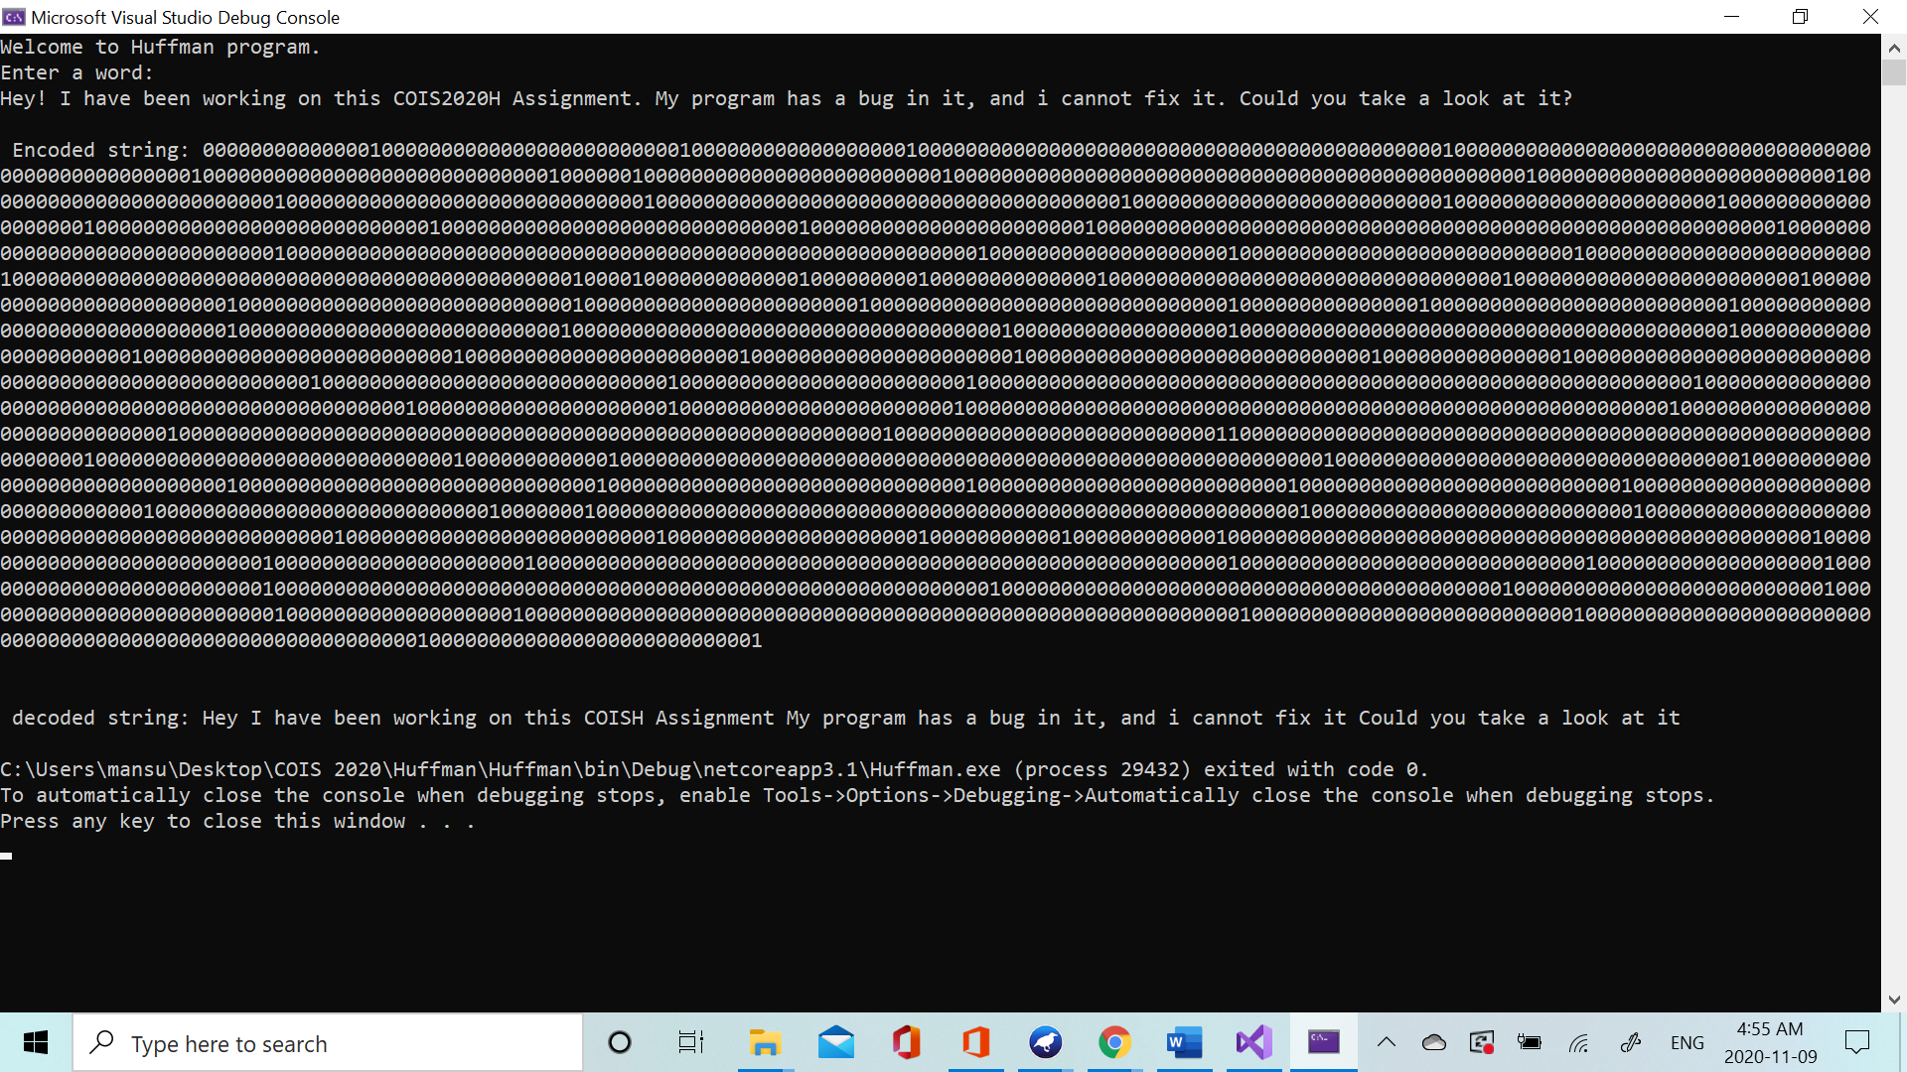

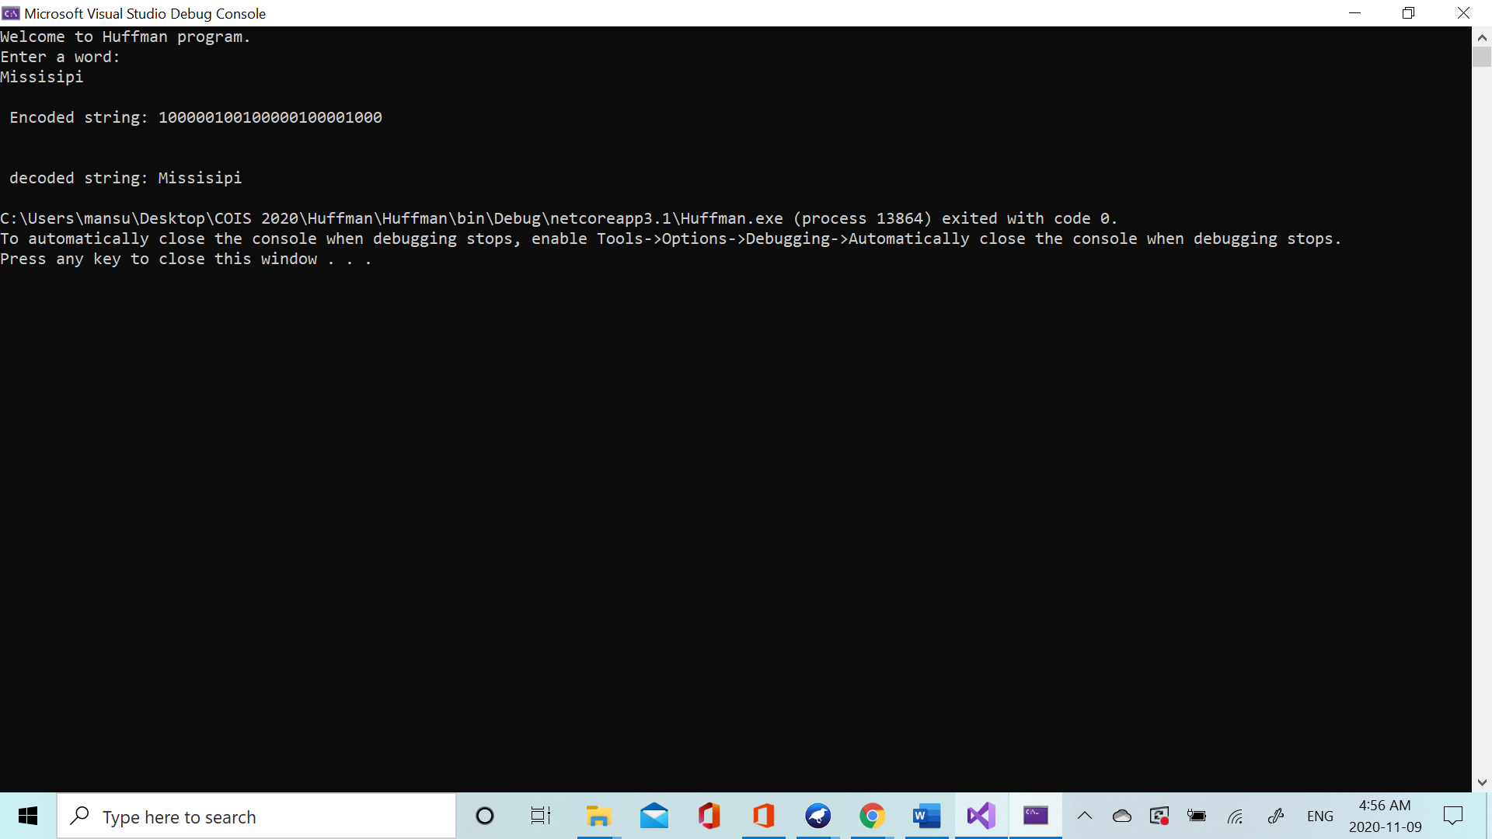

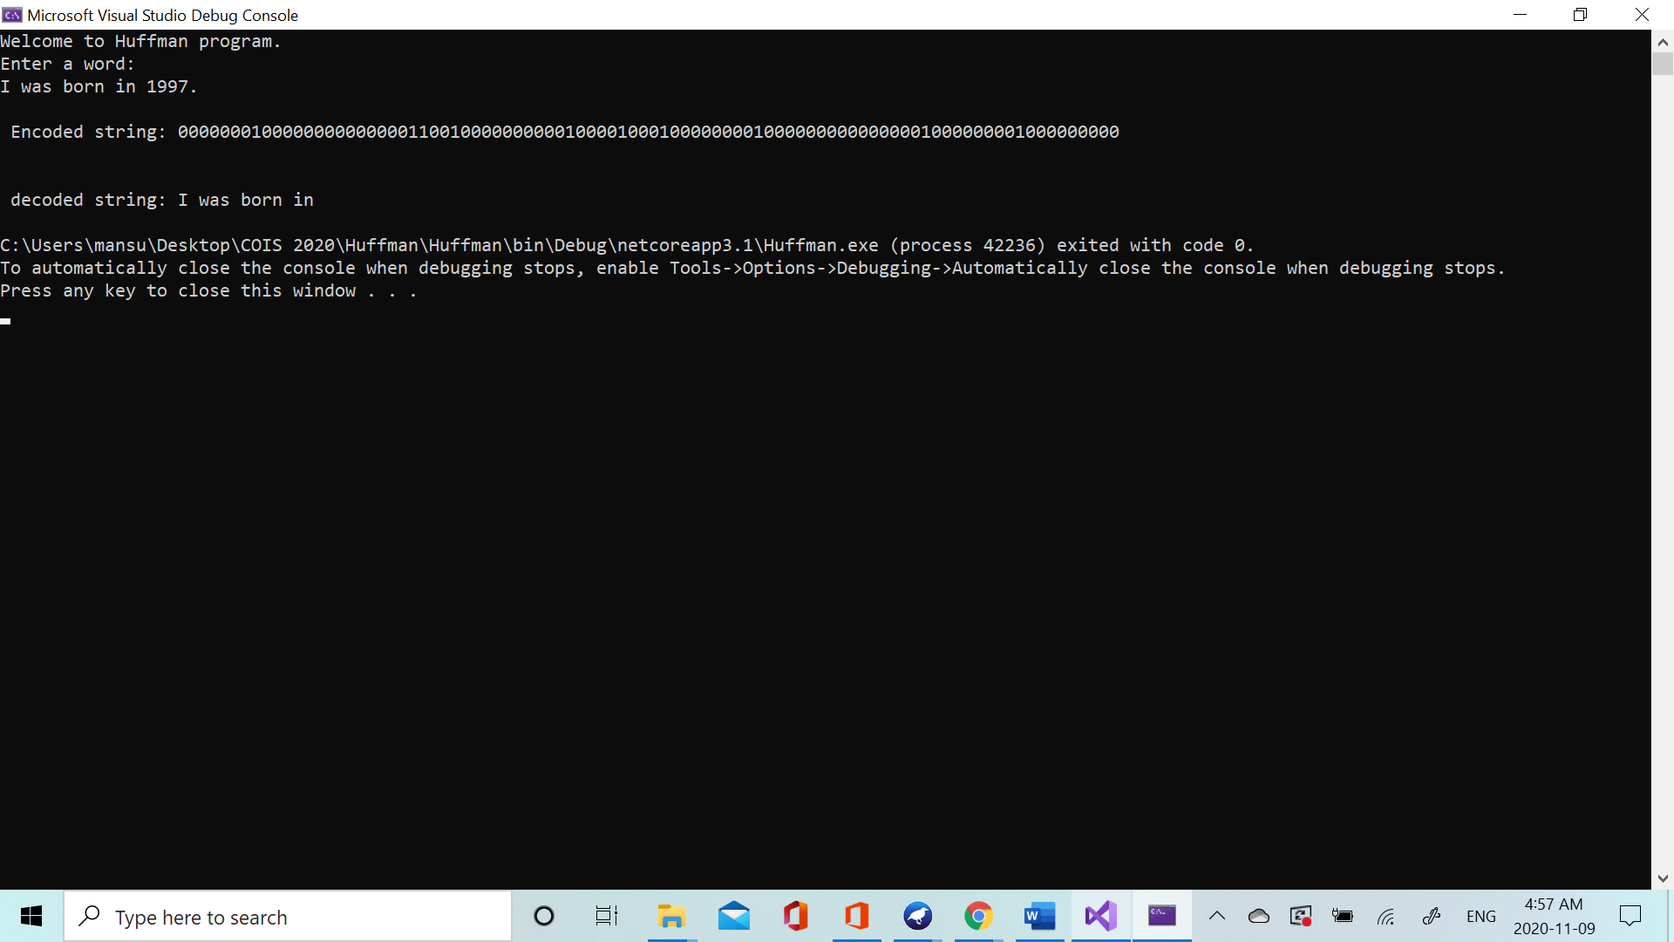

**Using excessive spaces:**

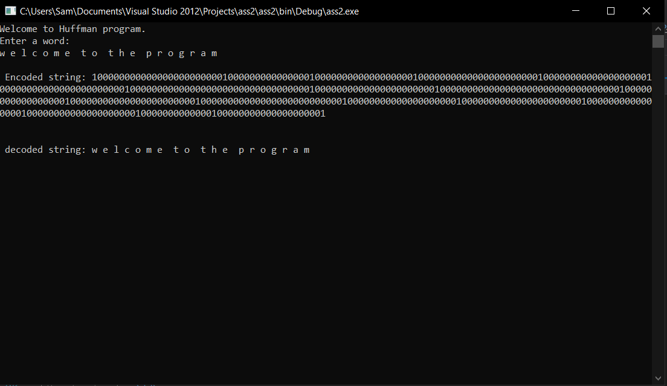

**Using only characters(expected to have no result):**

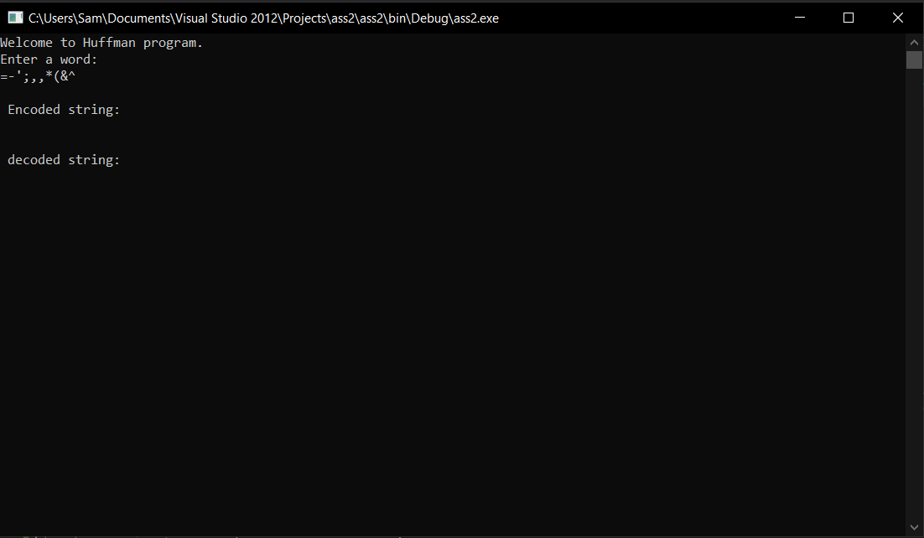

**Spanish Writing with a special character:**

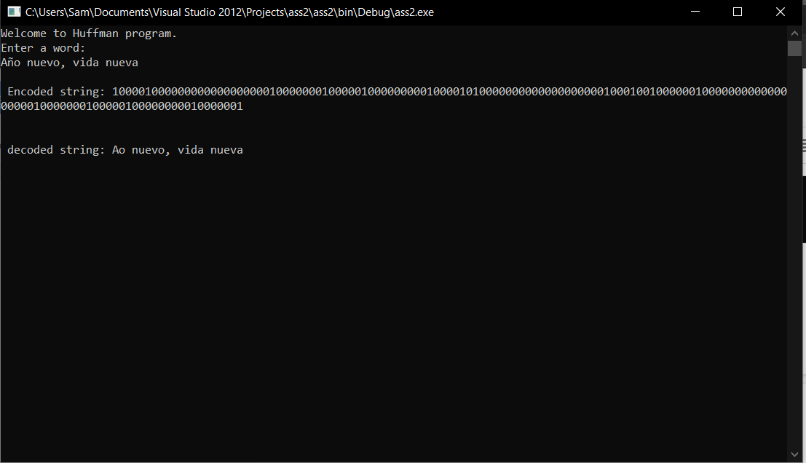

**Backwards writing:**

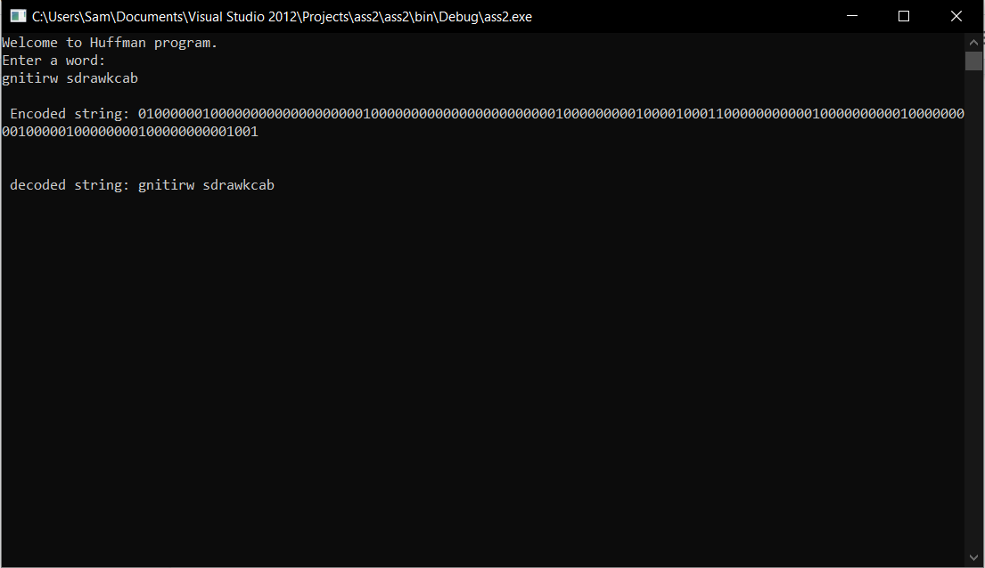

**Testing with 0’s and 1’s(no result expected):**

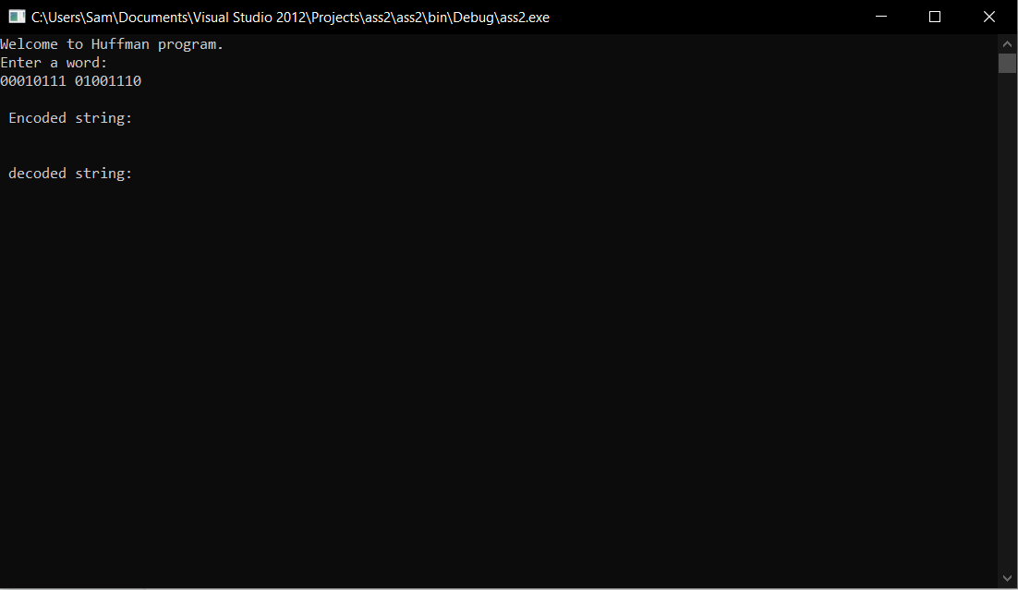

**Testing with all capital letters:**

